MBED LPC 1768 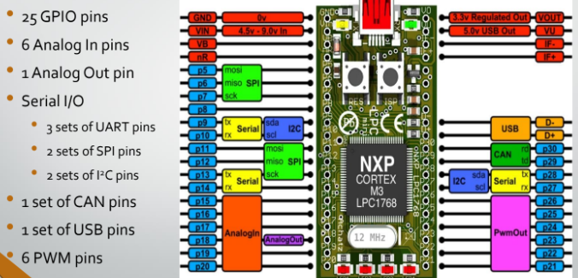
picture 1
Introduction
Development board is a printed circuit board containing a microcontroller with other hardware components. It main functionality is to reads inputs from sensors, processes data, and controls connected electronic components. The mbed LPC1768 is one of the development board. In Universiti Teknikal Malaysia Melaka (UTeM) the Mbed LPC1768 is used to introduce students to the ARM Cortex-M3 architecture which is widely used in other industry standard board like the STM32 Bluepill.
Firstly, the mbed LPC1768 is equiped with the NXP LPC1768 microcontroller unit(mcu). The NXP LPC1768 is a 32-bit mcu based on the ARM Cortex-M3 architecture, and it was released in 2009 by NXP Semiconductor. Due to it’s ARM architecture, the microcontroller is superbly efficient allowing usage in low power like in a remote controller car or smart house system. The dev board come with a compact rectangle form factor of 54 mm x 26 mm priced at $56.35 usd or RM253.58 under official NPX listing. This board features plethora kind of interfaces as per picture 1 allowing the mcu to connect to devices with many different kinds of communication protocols. For example, the CAN bus protocol which is used a lot in automotive industry.
Body 2 usage
Conclusion

LPC 1768 Datasheet https://pessina.mib.infn.it/CROSS/html/File_pdf/LPC1768_UM10360.pdf
The LPC176x/5x is an ARM Cortex-M3 based microcontroller for embedded applications requiring a high level of integration and low power dissipation. Page 5
The ARM Cortex-M3 is a general purpose 32-bit microprocessor, which offers high performance and very low power consumption. Page 11
NPX 1768 Product Datasheet
https://www.nxp.com/docs/en/data-sheet/LPC1769_68_67_66_65_64_63.pdf
Official Product Listing
https://www.nxp.com/products/processors-and-microcontrollers/arm-microcontrollers/general-purpose-mcus/lpc1700-arm-cortex-m3/arm-mbed-lpc1768-board:OM11043

https://www.pololu.com/product/2150
Compact module: 54 mm × 26 mm
a free online IDE and C++ compiler means that no software installation is required. Downloading programs is as simple as using a USB flash drive (no external programmer is necessary).

